Solution Architecture
(Automated Network Request Management)
Date | 26 September 2026
Team ID | ________________
Project Name | Automated Network Request Management
Maximum Marks | 4 Marks
1. Introduction
Solution architecture bridges the gap between a business problem and its technology solution. For Automated Network Request Management, it defines how users, ServiceNow interfaces, workflow automation, business logic, data storage, integrations, reporting and infrastructure work together to manage network requests from submission to closure.
2. Objectives of the Solution Architecture
Provide a clear technical structure for the proposed solution.
Map business requirements to ServiceNow platform components.
Define request, approval, fulfillment and status data flows.
Support security, auditability, scalability and maintainability.
Provide extension points for future enterprise and network integrations.
3. High-Level Solution Architecture
The following diagram presents the proposed architecture of the Automated Network Request Management solution.
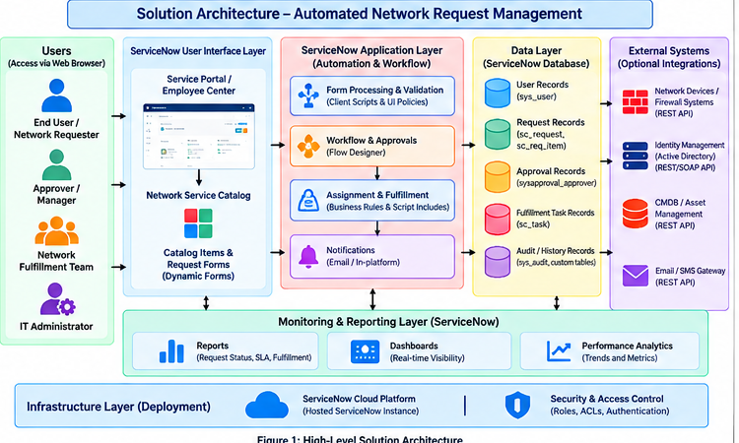
Figure 1: High-Level Solution Architecture
4. Architecture Description
4.1 User Layer
Includes End Users/Network Requesters, Approvers/Managers, the Network Fulfillment Team and IT Administrators. Each role accesses only the functions required for its responsibilities.
4.2 User Interface Layer
ServiceNow Employee Center or Service Portal provides the user interface. The Network Service Catalog and catalog items provide standardized request forms.
4.3 Application Layer – Automation & Workflow
Client Scripts and UI Policies support form behavior and validation. Flow Designer automates approvals, assignment, fulfillment tasks and notifications. Business Rules and Script Includes support server-side processing and reusable logic.
4.4 Data Layer
The ServiceNow platform database stores user, network request, approval, fulfillment task and audit/history information.
4.5 External Systems
Optional REST/SOAP integrations can connect to network devices, firewall systems, identity management, CMDB/asset systems or notification services.
4.6 Monitoring & Reporting
Reports and dashboards provide visibility into request status, SLA information, fulfillment activity and operational trends.
4.7 Infrastructure & Security
The solution is hosted on the ServiceNow cloud platform. Roles, ACLs, authentication and authorization provide controlled access and auditability.
5. Architecture Components and Functions
Layer / Component | Key Functions
Users | Submit requests, approve requests, perform fulfillment and manage configurations.
Service Portal / Employee Center | Provides access to the service catalog and request forms.
Service Catalog | Provides standardized network request categories and catalog items.
Client Scripts & UI Policies | Control form behavior, mandatory fields and dynamic fields.
Flow Designer | Automates approval routing, assignment, task creation and notifications.
Business Rules & Script Includes | Provide server-side processing and reusable business logic.
ServiceNow Database | Stores users, requests, approvals, tasks and audit information.
External Integrations | Optional integration with network, identity, CMDB/asset or notification systems.
Reports & Dashboards | Provide request, SLA, fulfillment and performance visibility.
Security | Roles, ACLs, authentication and authorization protect access.
Infrastructure | ServiceNow cloud platform hosts the proposed solution.
6. Request Processing Flow
Requester → Service Catalog → Network Request Form → Validation → Approval → Assignment → Network Fulfillment → Status Update → Notification → Closure → Audit / Reporting.
7. Architectural Benefits
Standardized network request intake.
Reduced manual coordination through workflow automation.
Role-based access and auditability.
Improved request visibility and reporting.
Scalable addition of request types, workflows and integrations.
8. Conclusion
The proposed architecture uses ServiceNow as the central platform for Automated Network Request Management. The layered design connects standardized request intake with validation, approvals, fulfillment, notifications, tracking and audit capabilities while providing a structured foundation for security, scalability and future integrations.

